CNBTA IS EXCITED TO HOST

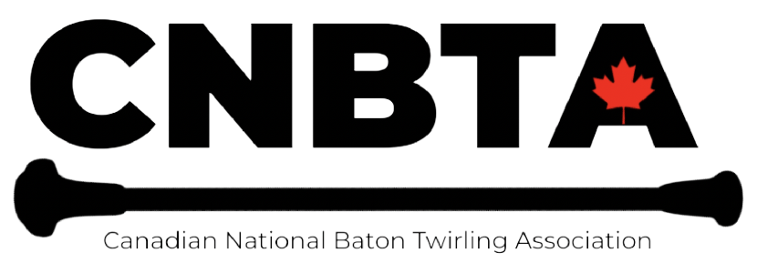

THE ROAD TO LIVERPOOL
CNBTA- IBTF SELECTION TRIALS
SATURDAY MAY 27, 2023

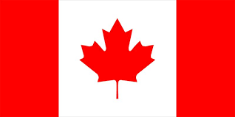

WHO IS HEADING TO LIVERPOOL

LOCATION:
GEORGIAN COLLEGE
1 Georgian Dr, Barrie, ON L4M 3X9

CNBTA SANCTION #000-039

FOR MORE INFORMATION, CONTACT:

CNBTA President- SATYNE WARD
CNBTApresident22@gmail.com

OR
CNBTA Technical Director- JENN TITTERTON
CNBTA.Technicaldirector@gmail.com

**It is imperative to send a correct email with entries to be notified of any of updates or changes to schedule prior to the event**

GENERAL INFORMATION

Anyone participating in the 2023 CNBTA IBTF Trial selection are welcome to use the GYM for practice on Friday May 26, during the Miss Majorette Pageant. There will be a designated area for those in the qualifier to practise.

SATURDAY MAY 27 - DOORS OPEN AT 7:30AM COMPETITION WILL BEGIN AT 8:30AM

ORDER OF TRIAL SELECTION EVENTS -- Please note times are approx. and will be updated once the official set system has been finalized.

8:30- 9:15 X STRUT
9:15-10:00 ARTISTIC TWIRL
10:00-10:20 ARTISTIC PAIR
10:20-10:30 BREAK
10:30-11:30 SOLO
11:30-11:45 DUET
11:50-12:15 3 BATON
12:15-1:00 2 BATON
Times are approx. events will start as the previous one completes.

- Awards and announcement of the 2023 CNBTA IBTF Nation Cup & World Team will be announced Sunday at the completion of the Provincial Title events. All athletes are asked to be dressed in costume for the awards ceremony.

Entry Fees and Deadlines:

- CNBTA now accepts E-transfers, however should you require another form of payment we ask that you contact our treasurer directly to arrange prior to deadline (cnbtatreasurer@gmail.com).
- E-transfers payable to cnbtapayments@gmail.com Password: CNBTA23
*entries are not accepted until payment is made*

** A $5.00 per day late fee will be applied if payment is made after
deadline date, without prior arrangements**

Online Entry Deadline: FRIDAY APRIL 14, 2023 - the online entry form will be disabled Friday April 14, 2023

Payment Deadline: FRIDAY APRIL 14, 2023

Late entry deadline: NO LATE ENTRIES WILL BE ACCEPTED

Verification: Coaches will receive a copy of their entire group's entry and will have a deadline for corrections or errors without fee. After the deadline NO changes will occur.

All competing athletes from Canada must hold a current CNBTA membership, a CANADIAN Passport
and ensure they have met all previous requirements to be a part of the CNBTA IBTF National Team.

THE FOLLOWING REQUIREMENTS MUST BE MET BEFORE YOU CAN ENTER THE CNBTA IBTF TRIAL SELECTIONS:

- Met CNBTA Membership requirements
- Has a valid CANADIAN Passport - within 6 months of the IBTF Event (cannot expire before February 2024)
- Has submitted a CNBTA intent qualification form & submitted $200 deposit - DUE Oct 31, 2022
- Has entered the 2023 CNBTA Provincial Championship events in the events you plan on qualifying for
- Paid your IBTF team member deposit on this entry
- Ensure you attend and compete in events you have earned a Team spot on (note if you fail to attend Canadians in the events you qualified you will be immediately releasing your spot to the next athlete with no refunds)
- Have a CNBTA member coach who is attending the IBTF event with you (or name a designate, everyone must have an official technical liaison that CNBTA can communicate information with)
- Have ensured if you are NOT on CNBTA Package A that you are staying in a designated Stay & Play location, as per IBTF rules and submitted this information with your entry
- Have submitted health form documentation to CNBTA President
- Has submitted a Photo ID for IBTF badge, and a copy of your passport as per IBTF requirements
- NON Package A team members - sign and submit your acceptance form to confirm National Spot

**Please ensure all participants, coaches and spectators read & understand the CNBTA CODE OF PRACTICE.

Any questions, please contact CNBTA President -Satyne Ward CNBTApresident22@gmail.com

A souvenir Program will be made for purchase which will include all Set systems for the weekend. See entry form to pre order

Please note: ALL IBTF Rules including restrictions for each level of event will be in full effect as well as all penalties as per IBTF Rule Book. We will be following the IBTF guidelines, and penalties for this trial selection.

IBTF music will be used for all the IBTF Trial selection events.

The number of Berths that will be granted to CNBTA in accordance with the IBTF Policy Manual where 2 National federations have not yet united:

NATION CUP TEAM
Youth, Junior, Senior, Adult Level B- 3 CNBTA spots per individual event in each age discipline
Youth, Junior, Senior, Adult Level A- 3 CNBTA spots per individual event in each age discipline
Junior, Senior Level B Duet & Artistic Pair- 3 CNBTA spots in each age discipline
Junior, Senior, Level A Duet & Artistic Pair- 3 CNBTA spots in each age discipline
Level B Artistic Team- 1 CNBTA spot
Level B Twirl Team- 1 CNBTA spot
Level A Artistic Team- 1 CNBTA spot
Level A Twirl Team- 1 CNBTA Spot
WORLD CHAMPIONSHIPS

Youth, Junior, Senior, Adult- 3 CNBTA Spots per individual event in each age discipline
Junior, Senior Duet & Artistic Pair- 3 CNBTA spots per event in each age discipline
Artistic Team- 1 CNBTA Spot
Twirl Team - 1 CNBTA Spot
Twirl Corps - 1 CNBTA Spot
Artistic Group-1 CNBTA Spot

**At this time CNBTA will not be sending any Majorette events to the IBTF Competition**

***Please anyone who has entered both CBTF and CNBTA trial selections and earns a berth with CBTF is NO LONGER eligible to earn one of the CNBTA Spots. You may compete for a score sheet but will not be factored into the FINAL results or awards presentation. No refunds available for this event***

AGE CATEGORY

For the CNBTA IBTF Trial selection the following ages are being used:

Athletes age is determined by their age as of December 31, 2023
Youth (12 - 14 years) Junior (15-17 years) Senior (18-21 years) Adult (22 and over)
There is NO team ages for team or group events however min. Age to be on a team is 12 as of December 31, 2023
Junior Duet- Combined ages (24-34 years) Senior Duet (35 years and older)
Junior Artistic Pair (both members must be 17 or under) Senior Artistic Pair (one or both athletes over 18 years)

AWARDS

World Team medals will be awarded to the TOP 3 in all ages, levels & events which will represent the CNBTA IBTF Nation Cup & World Team.

The Top Team in each event will be awarded medals.

FOOD AVAILABILITY: At this time CNBTA will not be able to offer food however when the set system goes out we will provide a list of food locations nearby. We may look into a catered delivery of box lunches available for purchase through Georgian.

TRIAL SELECTION INDIVIDUAL ENTRY FORM CAN BE FOUND VIA THIS LINK
https://form.jotform.com/230544665024048

TRIAL SELECTION TEAM ENTRY FORM CAN BE FOUND VIA THIS LINK
https://form.jotform.com/230593677001050

HEALTH Documentation that must be signed and submitted to the CNBTA president. You can scan and email document to cnbtapresident22@gmail.com.

You may submit your health documentation in person at the 2023 Regional Championships April 1 (there will be a place to drop all IBTF info).

https://docs.google.com/forms/d/e/1FAIpQLSe047ZGJ8DwdrsrZcuI9kwxFLaywth5kca_nLizqIU08Mhh5Q/viewform?usp=sf_link

BADGE PHOTO - ALL athletes, coaches & officials with the CNBTA IBTF Contingent must upload a passport size head shot at time of entry. Please use this drop box link to upload your photos

https://www.dropbox.com/scl/fo/k8jyl31p5me6vdvwhtc57/h?dl=0&rlkey=t9pbi10o2g2ij8d03ek3hfvij

PASSPORT COPIES- All athletes must upload a photocopy of their passport. The photo page with all clear and accurate information displayed. Please use this drop box link to upload your passport

https://www.dropbox.com/scl/fo/p2yizhmw4h0kpmk2b5f00/h?dl=0&rlkey=683rp57mm2o20lb0r53cymg4h

NON-PACKAGE A CONTINGENT MEMBERS- Anyone who is not on the package A CNBTA contingent trip must sign this form to confirm your acceptance once a team spot has been earned.
https://docs.google.com/forms/d/e/1FAIpQLSepUWeczHgaBg0KhwMnPmI6lAQeyx3fROaJ_uD47j6AoDHnlw/viewform?usp=sf_link

