CNBTA IS EXCITED TO WELCOME OUR ATHLETES TO THE . . .
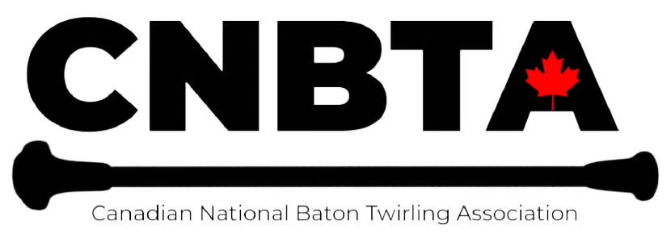

2026 REGIONAL CHAMPIONSHIPS
Featuring:

Regional Cup

Regional Pageant

March 29th 2026
Doors open at 8am
Contest begins at 830am

LOCATION: DR JM DENISON SECONDARY SCHOOL,
135 BRISTOL RD,
NEWMARKET

CNBTA SANCTION #000-049

For more information, please contact:

CNBTA President: Satyne Ward
Cnbtapresident22@gmail.com

CNBTA Technical Director: Krista DiStasi
CNBTA.technicaldirector@gmail.com

Please ensure that you are sending the correct email with entries to remain up to date on event information
Doors open and at 830am
Please be respectful to those setting up and wait until you are let in, as per entry rules. We encourage everyone to arrive at least 30 minutes prior to your first event. The timing of events is approximate and will be based on the number of registrants for each event. There will be no refunds for missed events.

Events: Please refer to the CNBTA rulebook for information on event rules including determining an athlete’s level and event restrictions.

Deadline and Payment: Entries and payment due date: February 27th 2026
**Late fee of $25 for payments or entries that arrive after Feb 27th 2026

All entry fees to be e-transferred to: cnbtapayments@gmail.com
Password that must be used: CNBTA26
Please include the athlete’s name in the memo line
Entries are not accepted until payment is received. Not using the password provided above will have your e-transfer denied.

NOTE: If a club is sending a bulk payment, please send the CNBTA treasurer (cnbtatreasurer@gmail.com) a breakdown of the athletes’ fees to assist with processing.

Membership: All Canadian athletes must be a current CNBTA member. Please contact our CNBTA Technical Director. Please note that U.S.A participants will pay in Canadian funds and do not need to be a member of the CNBTA organization. Please keep in mind that CNBTA insurance coverage will NOT be applicable to U.S.A contestants.

Verification: Coaches will receive a copy of their athletes’/club entries and will have a deadline for corrections or errors. Corrections made after the deadline may not be accommodated.

Set System: A Set System will be used for all events. A copy of the final set system will be forwarded to all coaches prior to the competition.

Music: All individual events use the Standard WFNBTA Music. All Rhythmic and Team music is to be submitted to the CNBTA Dropbox link that will be sent to all coaches. Music must be uploaded to Dropbox no later than March 1st 2026.

RHYTHMIC:
Label: Lastname.firstname.level.age
RHYTHMIC DROPBOX LINK
https://www.dropbox.com/scl/fo/98kukgv260victp9ucg89/AIu7tuz4Ibz-graDR_n88Po?rlkey=pp84dmzcl0gkpae9fz9odpj7d&st=78q534gc&dl=0

TEAM:
Label: song name.club.event.age.level
TEAM DROPBOX LINK
https://www.dropbox.com/scl/fo/b5aby1gk3z1k0h7j8gixc/AJm0alweHmBTENCHmPVVXpM?rlkey=1f4ouyzlu8pf39omehvdgd3x2&st=g60uirj9&dl=0--

Accommodations: Accessibility accommodations for athletes must be communicated to the Technical Director a minimum of 48 hours prior to the competition to ensure accommodations can be met.

Regional Cup
Results in the cup event will count towards regular advancement.

Level | Event Requirements
Novice | Solo, 2-Baton
Beginner | Solo, 2-Baton, Artistic Twirl
Intermediate | Solo, 2-Baton, Rhythmic
Advanced | Solo, Rhythmic, Multi-baton (athlete decides on 2 or 3 baton and place points will be used for cup scoring. Scoring will only be used for tie breakers),

Regional Pageant
The pageant will follow the NBTA rules and regulations regarding combined events including dress regulations for each level of the pageant. If you are not familiar with these rules, please contact the Technical Director at CNBTA.technicaldirector@gmail.com or refer to the CNBTA Rule Manual on our website: www.cnbta.net.

Judging
Judges' decisions are final. Tabulated results are final 48 hours after the completion of the competition day. Any issues regarding the results of the contest need to be raised prior to results being final using the "Result Conflict Form" found on the website or at the contest. Any other concerns regarding the contest are to be brought to the attention of the Technical Director.

Age categories as of September 1, 2025
Primary (0-6) Juvenile (7-9) Pre-teen (10-12) Junior (13-15) Senior (16 and over)

INDIVIDUAL ENTRY FORM

https://form.jotform.com/230085349782058

TEAM ENTRY

https://form.jotform.com/243385451329258

